

Science Department

**Year 12 Chemistry ATAR**

**Test 6: Organic Chemistry**

Name: _____________________________

**Instructions to Students:**

1. 50 minutes permitted

2. Attempt all questions

3. Write in the spaces provided

4. Show all working when required

5. All answers to be in blue or black pen, diagrams in pencil.

|  |  |  |
| --- | --- | --- |
| **TOTAL** |  | **Final Percentage** |
| /56 |  |  |

Organic Chemistry Test

**Section 1 – Multiple Choice**

1. Which one of the following substances contains a different number of carbon atoms from all the others?

(a) 3-methylpentane

(b) ethylbutane

(c) 2-hexene

(d) methylcyclohexene

2. Which one of the following lists contains only the formulae of saturated straight chain hydrocarbons?

(a) C2H6, C5H12, C8H18

(b) C2H6, C4H10, C6H6

(c) C2H4, C3H6, C4H.

(d) CH4, C2H6, CH3COOH

3. Which formula represents a compound that is both a ketone and a carboxylic acid?

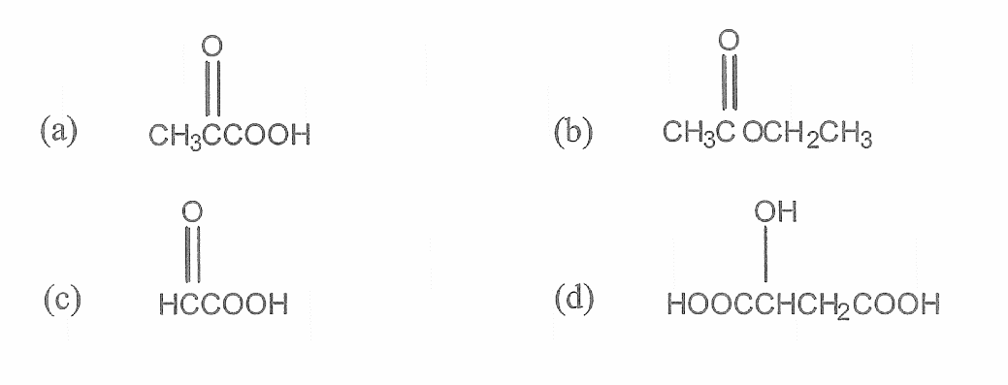

4. Which of the following substances has the LOWEST solubility in water?

* 1. HCOOH
  2. CH3CH2OH
  3. CH3COONa
  4. CH3CH2CH3

5. The chemical reactions that are TYPICAL of the compounds methane, ethene (ethylene) and benzene are known respectively as:

* 1. Substitution, substitution, addition.
  2. Substitution, addition, substitution.
  3. Addition, substitution, substitution.
  4. Addition, addition, substitution.

6. Which of these compounds are isomeric with butanol (C4H9OH)?

I. 2-methyl-2-propanol

II. 2-methyl-1-propanol

III. 2-methyl-1-butanol

* 1. I only
  2. II only
  3. I and II only
  4. II and III only.

7. The ester present in artificial strawberry flavouring is shown below:

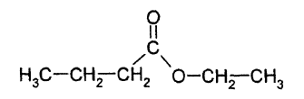

The two compounds which were used to make the ester were

* 1. Butanol and ethanoic acid.
  2. Ethanol and butanoic acid.
  3. Hexanol and acidified potassium dichromate.
  4. Hexanoic acid, hexanol and a suitable catalyst.

8. Which of the following statements concerning the compound with the following structure:

CH3CH2CHOHCH3

Is FALSE?

* 1. It is an isomer of butanol.
  2. It is a secondary alcohol.
  3. It can be oxidised by dichromate ion, forming a ketone.
  4. It can be converted into an ester by reaction with an aldehyde.

9. Which of the following is not an isomer of Pentane?

1.  b) 

c)  d) 

10. The IUPAC name for the structure below is:

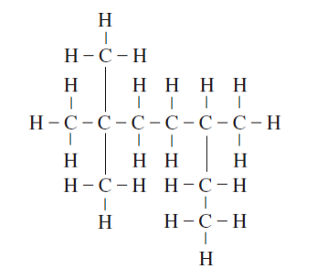

a) 2,2,5-trimethylheptane

b) 3,6,6-trimethylheptane

c) 2-ethyl-5,5-dimethylhexane

d) 5-ethyl-2,2-dimethylhexane

**Section 2 – Short Answer**

**YOU MUST SHOW ALL HYDROG*EN ATOMS IN YOUR STRUCTURAL DIAGRAMS***

1. Give the IUPAC name of the following structures:

|  |  |
| --- | --- |
| (a)    Name: | (b)    Name: |
| (c)    Name: | (d)    Name: |
| (e)      Name: | (f)      Name: |

(6 marks)

2. Give the full structural formula for the following organic chemicals (include all Hydrogens):

|  |  |
| --- | --- |
| 1. 3-aminoheptanoic acid | (b) 3,3,5-trimethylhexan-2-one |
| (c) 2-propylhexyl butanoate | (d) 3,6-dibromoheptan-2-one |
| (e) trans-but-2-ene | (f) 3,4-dichloro-cis-hex-2-ene |
| (g) 6-ethyl-6,7-dimethyl-4-propyloctanal | (h) 2,4,6-trinitromethylbenzene |

(8 marks)

3. For each of the situations described below, write a balanced redox reaction showing the changes that take place (there is no need to show the phase of the chemicals);

Give a brief observation of any major colour change that would be observed in any of the coloured reagents used to bring about the reaction.

(a) Excess acidified potassium dirchromate solution is added to pentan-1-ol.

|  |
| --- |
|  |
|  |
|  |
|  |
|  |
|  |
|  |

1. Limited **dilute** acidified potassium permanganate is added to 2-methylpropan-2-ol.

|  |
| --- |
|  |
|  |
|  |
|  |
|  |
|  |
|  |

(6 marks)

4. DRAW and NAME the major organic PRODUCT or PRODUCTS in the following reactions assuming appropriate conditions. NB. No balancing is required.

1. Ethene and steam under appropriate reaction conditions.

1. cyclopentane and bromine.

1. Ethanoic acid and methanol.

1. 2,3-dimethylpent-1-ene and fluorine gas.

(8 marks)

5. An organic compound known to contain only C, H, N and O was analysed by initially burning a 5.2246g sample which produced 10.5632g of CO2 and 4.8677 g of H2O. A second sample (1.367g) was oxidized separately to NO2 and it was determined that 0.01576 mol on NO2 was produced.

(a) Find the empirical formula.

(9 marks)

(b) A 2.090g sample is vapourised and occupied 200mL at 150 kPa and 25°C.

Determine the molecular formula.

(2 marks)

(c) Had the organic compound turned blue litmus pink, draw a possible molecular structure and name it.

(2 marks)

6. Hexane, hexanal and hexanoic acid all contain the same number of carbon atoms but display different physical properties. Their boiling points are given in the table below.

|  |  |
| --- | --- |
| **Organic compound** | **Boiling point**  **(°C)** |
| hexane | 68 |
| hexanal | 130 |
| hexanoic acid | 205 |

Account for the difference in boiling points of the three compounds.

(5 marks)

|  |
| --- |
|  |
|  |
|  |
|  |
|  |
|  |
|  |
|  |
|  |
|  |
|  |
|  |
|  |
|  |

**End of Test**